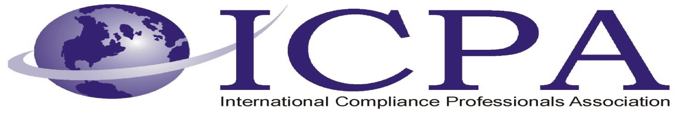

Job Opportunity

Company | Alcoa
Job Title | Trade Compliance Manager
Location | New Kensington, PA
Salary Range | Depends upon qualifications & experience
Relocation Assistance | Yes

Job Description / Responsibilities / Requirements

Alcoa has an exciting opportunity for a Trade Compliance Manager to work at the Alcoa Technical Center located in Alcoa Center (New Kensington) PA, a suburb of Pittsburgh. The Alcoa Technical Center (ATC) is Alcoa’s largest research, development, and applied engineering laboratory. Alcoa Technical Center occupies a 127-acre campus with an additional 2,019 acres of rolling countryside. This facility is the world’s largest light metals research and development center with a full range of lab capabilities, from bench-scale to full production-scale equipment. The facility has a diverse, multi-lingual workforce holding more than 100 Doctorate and 200 Master’s Degrees.

The key responsibility of the position is to design, implement and manage the Trade Compliance Program at ATC and serve as the EXIM (Export/Import) Empowered Official providing direction and guidance in all areas of Trade Compliance.

Basic Qualifications
  - BS Degree
  - Minimum of 5 years experience in Trade Compliance or related field
  - Demonstrated ability to understand and interpret associated regulations and apply those regulations to technology development(s)
  - Due to ITAR restrictions, applicants must be US citizens or have permanent resident status
Preferred Qualifications
  - Expert knowledge of trade compliance regulations, including: International Traffic in Arms Regulations (ITAR), Export Administration Regulations (EAR), Customs and Border Protection (CBP), Office of Foreign Assets Control (OFAC), and other applicable U.S. government export/import agencies
  - Understand the administrative processes to prepare, submit, execute and manage applicable government licenses and submissions including State/Commerce Department licenses, Commodity Jurisdictions, CCATS, etc.
  - Understand the process to determine and document HTS/ECCN/ITAR classifications for products, technologies
  - Understand the essential elements of a compliance/audit process relative to trade compliance
  - Strong interpersonal skills to effectively represent Alcoa and interact with governmental agencies, internal and external counsel, ATC management and technologists, personnel from other BU’s and RU’s, customers and suppliers

Contact Information to Apply

Please apply online at:

https://sjobs.brassring.com/1033/ASP/TG/cim_jobdetail.asp?partnerid=16&siteid=56&AReq=11415BR&Codes=ICPA

