There are a ton of canned reports that you can download without any hassle straight from the tool.... I think that with what you've described the best canned report would be AM-003... It will provide you Filer code, entry number, entry date, file create date, IOR number (helpful if you are managing multiple), Country of Origin, Country of Export, Port of Entry, MID, Entry Type, HTS, TEV, duty, and a couple other items if for NAFTA, UOM and recon.
ACE is super easy to use... if the AM-003 report (or the other canned ones) don't have exactly what you need there is a modify function that you can use to tweak the data you pull from pre-existing queries rather than trying to pull several different reports and put them together.
Instructions
When you are looking at the query you'll see a "MODIFY" button below the report title (see below screen shot with red circle), go a head and click that...
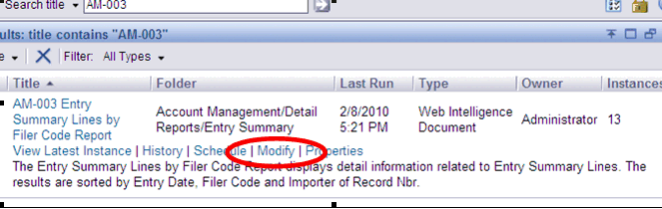
It will open a prompt just like your standard canned reports... requesting date ranges,filer codes, IOR number, ect. So select what you want just like any other report and click the "RUN QUERY" button.
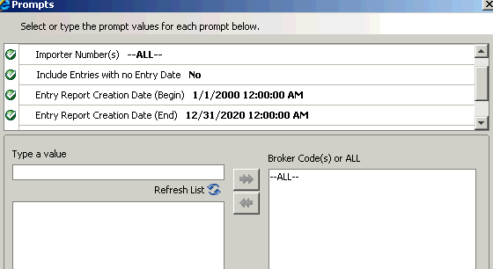
The standard report will run... When it does, you're tool bar is different here than in the canned report. You can select the "EDIT QUERY" Icon (see below in red circle)
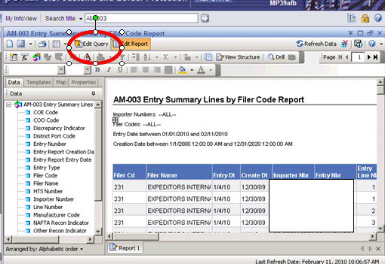
After that you're in the design menu. From here you'll have a laundry list of data elements in the left scroll bar (red circle) that you can choose from... just drag and drop into the objects field. When you finish picking what you want, just click the "RUN QUERY" icon (blue circle) and the report will re-run with the elements that you selected.
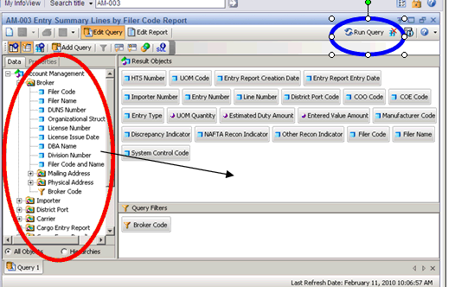
Fairly simple to run a custom report. You can pull in items like MPF, HMF, ADD, CVD and a whole host of other things. All the reports have the modify function. The only hiccup is that you can't pull all the available data elements into all the reports... hope this helps.

